**INTERNSHIP PROJECT REPORT**

**ASHOK LEYLAND UNIT 1, HOSUR**

**BIG DATA LATENCY ANALYSER**

By

**RISHIRAM B**

**REG NO:** RA2211026010553

**B.Tech CINTEL – AI/ML**

**DURATION:** 06/12/23 – 08/01/24

Under the guidance of   
**Ramakrishna Podapati (ALIMS)**

Asst. General Manager, ALIMS

AI & Emerging Technologies



**FACULTY OF ENGINEERING AND TECHNOLOGY**

**SCHOOL OF COMPUTING**

**SRM INSTITUTE OF SCIENCE AND TECHNOLOGY**

**KATTANKULATHUR**

**E-mail: rishiram20757@gmail.com**

**Mobile no: 8667796632**

**BONAFIDE CERTIFICATE**

Certified that **Rishiram B** from **SRM INSTITUTE OF SCIENCE AND TECHNOLOGY, KATTANKULATHUR** has successfully completed the one-month project training program at Ashok Leyland Limited, Plant-1, Hosur-635109. The project has been titled as **“BIG DATA LATENCY ANALYSER”**. The duration of the project was from 06/12/2023 to 08/01/2024.

# SIGNATURE SIGNATURE

Ramakrishna PodapatiRamesh G

Asst. General Manager, ALIMS Divisional Manager,

AI & Emerging Technologies HR – Training & Development

Ashok Leyland Unit 1 – Hosur Ashok Leyland Unit 1 - Hosur

**ACKNOWLEDGEMENT**

I would like to express my special thanks of gratitude to Ashok Leyland, Unit II, Hosur for giving me a wonderful opportunity to carry out my project work. The learning experience was extremely good, and this will help in developing my career.

I express my sincere respect and gratitude to my project guide, Mr. Ramakrishna PodapatiAsst. General Manager, ALIMS AI & Emerging Technologies who has given his valuable support and suggestions from time to time in successfully completing this project work.

I convey my sincere thanks to Mr. Ramesh G, Divisional Manager – HR Training & Development for allowing me to undertake this project.

**DECLARATION**

I hereby declare that the project entitled " BG DATA LATENCY ANALYSER ", submitted as part of the internship program, has been carried out by me. I declare that the project has not formed the basis for the award of any degree, associate ship, fellowship, or any other similar titles elsewhere. Further, I declare that I will not share, re-submit, or publish the code, idea, framework and/or any publication that may arise out of this work for academic or profit purposes without obtaining the prior written consent of the Course Faculty Mentor and Course instructor.

Place: Hosur

Date: 08/01/2024 Name: Rishiram B

**ABSTRACT**

The Project aims to investigate the Data latency (delays) of the vehicles and to analyze the problems with the help of various parameters provided by the ECU to the database. The analysis aims to Examine the latency between the vehicles and the company Database (server). By Utilizing various types of graphs, we can precisely quantify and categorize the latency Occurrences.

The development of this analysis utilizes modern technologies and frameworks, ensuring scalability, security, and performance. Using Pandas From python library to create an environment and implement the ideas and using several other packages to visualize the data that is been taken from the company database for educational purposes.

Throughout the development lifecycle, established Analyze best practices such as agile methodologies will be followed. This iterative approach allows for continuous improvement, with frequent testing and deployment to ensure the Analyzer’s reliability and stability.

The implementation of this Analyzer will bring several benefits to organizations, filtering out the Redzone of network, Finding out the best Possible service provider, ECU (Electronic control Unit) Performance. The visual-based nature of the application will make the process of filtering and understanding very easy and fast.

**TABLE OF CONTENTS**

|  |  |  |
| --- | --- | --- |
| CHAPTER NO | TOPICS | PAGE NO |
| 1 | INTRODUCTION | 7 |
| 2 | ABOUT THE PROJECT | 15 |
| 3 | DATA ANALYSIS | 16 |
| 4 | DATA VISUALIZATION | 26 |
| 5 | IMPLEMENTATION | 30 |
| 6 | TABLEAU | 33 |
| 7 | CONCLUSION | 37 |
| 8 | REFERENCES | 38 |

**CHAPTER 1**

**INTRODUCTION**

* 1. **INDUSTRY OVERVIEW**
     1. **INDUSTRY PROFILE IN GLOBAL SCENARIO**

**Ashok Leyland** is an Indian automobile manufacturing company specializing in commercial vehicles. It is one of the largest manufacturers of trucks and buses in India and has a significant presence in the global market as well.

Ashok Leyland had a global presence in over 50 countries, including the United Arab Emirates, Bangladesh, Sri Lanka, Kenya, and various countries in Europe. The company has established manufacturing facilities and assembly plants in several locations worldwide, allowing it to cater to the demand for commercial vehicles in different markets.

Ashok Leyland had been actively pursuing international expansion to increase its global footprint. The company has entered strategic partnerships and collaborations with other automobile manufacturers and distributors in various countries. These partnerships aimed to leverage the local market knowledge and distribution networks of the partners to enhance Ashok Leyland’s presence and sales in those regions.

Furthermore, Ashok Leyland had been focusing on research and development initiatives to develop technologically advanced and environmentally friendly vehicles. The company had been investing in electric and hybrid vehicle technologies to align with the global trend toward sustainable transportation solutions. Ashok Leyland had showcased electric and hybrid prototypes and had been working on bringing these vehicles to market in the coming years.

**1.1.2 INDUSTRY PROFILE IN INDIAN SCENARIO**

**Ashok Leyland** is a well-known Indian automotive company that specializes in the manufacturing of commercial vehicles.

Ashok Leyland Limited is a flagship company of the Hinduja Group, one of India’s leading business conglomerates. It was founded in 1948 and is headquartered in Chennai, Tamil Nadu. The company primarily manufactures trucks, buses, and other commercial vehicles for various applications.

Ashok Leyland offers a diverse range of commercial vehicles catering to different segments of the market. Its product portfolio includes trucks, tippers, tractors, buses, and defense vehicles. The company manufactures vehicles for both domestic and international markets

Ashok Leyland has a significant presence in the Indian commercial vehicle market. It is one of the largest manufacturers of trucks and buses in the country. The company holds a strongmarket share in segments such as medium and heavy-duty trucks, city buses, and intercity buses.

Ashok Leyland operates multiple manufacturing plants across India. It has manufacturing facilities located in Chennai, Pantnagar, Ennore, and Hosur. These plants are equipped with advanced technologies and adhere to global manufacturing standards.

Ashok Leyland has a dedicated research and development center called the Ashok Leyland Technical Center (ALTC) in Chennai. The company focuses on developing innovative technologies, improving fuel efficiency, enhancing vehicle performance, and meeting regulatory requirements.

Ashok Leyland has shown a commitment to sustainability and green initiatives. The company has been actively working on electric mobility solutions and has launched electric buses and commercial vehicles in India. It aims to contribute to the country’s transition towards clean and sustainable transportation.

Ashok Leyland emphasizes customer support and after-sales service. It has an extensive network of service centers and authorized dealerships across India, ensuring timely maintenance and repair services for its vehicles.

Ashok Leyland has received numerous awards and accolades for its products, manufacturing capabilities, and sustainable practices. It has been recognized for its excellence in areas such as innovation, quality, and customer satisfaction.

* 1. **COMPANY OVERVIEW**
     1. **ABOUT THE COMPANY**

**Ashok Leyland**, the Hinduja Group’s main company, is the world’s fourth-largest bus maker, India’s second-largest producer of commercial vehicles, and the country’s nineteenth-largest producer of trucks.

It is a multinational Indian carmaker specializing in commercial vehicles. It is part of the Hinduja Group and is headquartered in Chennai, Tamil Nadu. The company was founded in 1948 and has since grown to become one of India’s leading manufacturers of commercial vehicles.

It offers a diverse range of vehicles, including trucks, buses, and special use vehicles. Buses, tippers, tractors, heavy-duty trucks, medium-duty trucks, heavy-duty trucks, intermediate commercial vehicles, and Defense vehicles comprise their product line. They provide services to a variety of industries, including logistics, construction, mining, transportation, and public transportation.

The company has expanded its presence in the Indian market and they also operate on a global scale. Ashok Leyland cars are imported by more than 50 countries worldwide, including those in Asia, the Middle East, Africa, and South America. They have manufacturing facilities in the United Kingdom, the United Arab Emirates, and India.

Ashok Leyland is well-known for its technological achievements and commitment to sustainability. They developed hybrid and electric vehicles to address environmental concerns while also meeting the evolving needs of the industry. In addition, the company has focused on developing alternative fuel technologies for its vehicles, such as compressed natural gas (CNG) and liquefied natural gas (LNG). In addition to vehicle manufacturing, Ashok Leyland offers extensive aftermarket services such as spare parts, maintenance, and repair. To assist their consumers, they have a large network of service centers and dealerships.

* + 1. **THE HISTORY**

Mr. Raghu Nandan Saran founded Ashok Leyland, and on September 7th, Ashok Motors was launched in partnership with the Austin Motor Company in England to make Austin automobiles. Production at the Ennore facility began in September. Soon after, the first locally produced Austin A40 rolled off the assembly plant north of Madras. The two businesses signed an agreement, and Ashok Motors was granted seven years of exclusive rights to import, assemble, and gradually make Leyland automobiles. Four Comet 350engine tippers sold to the Mangalore Tile Factory were the first Leyland chassis Ashok Motors built in Ennore. The government permitted the increased manufacture of Leyland commercial vehicles and awarded a license for the annual manufacturing of 1,000 Comets. Named after Raghu Nandan’s son, Ashok, the company was renamed ‘Ashok Leyland’ with equity participation from Leyland Motors, Ltd.

Titan, India’s first double-decker built with 50% local components, was unveiled. Power steering was originally used in commercial vehicles. The Indian Army received 1,000 units of the 64 “Hippo” Tipper, which was designed and manufactured in India. It has its own set of requirements. A permit was granted to make 10,000 vehicles per year.

Ashok Leyland’s income surpassed Rs. 1 billion for the first time. The “Viking,” the first bus with an alternator and a prominent front overhang that allowed for front access, was introduced on Indian highways.

The reactions of drivers to India’s first rear-engine bus, the “Cheetah,” were mixed. They claimed that they “could not hear the engine” even though it substantially lowered the heat. Former Tamil Nadu Chief Minister M. G. Ramachandran formally launched the company’s second factory, Hosur 1. The “Taurus,” the country’s first multi-axle truck, was released shortly after India’s first 13-ton truck, the “Tusker,” with a 125-horsepower engine, went on sale. India’s first vestibule Alternatively, the articulated bus introduced a completely new concept in urban transportation.

* + 1. **VISION:**

Be among the top Indian corporations acknowledged nationally and internationally for excellence in quality of its product and excellence in customer focus and service.

**1.2.4 MISSION:**

Is a leader in the business of commercial vehicles, excelling in technology, quality and value to the customer fully supported by the customer service of the highest order and meeting the national and international environmental and safety standards.

**1.2.5 THE JOURNEY**

Two brand-new manufacturing facilities were officially opened in Bhandara (Maharashtra) and Alwar (Rajasthan) in March and August, respectively. The company’s technical center in Vellivoyalchavadi, on the outskirts of Madras, was already outfitted with critical testing tracks. This was followed two years later by ISO 9001 certification. Namakkal, the most comprehensive driver training facility in India’s private sector, has been constructed in the heart of Tamil Nadu’s trucking community. Former Prime Minister Deve Gowda opened the second facility in Hosur in December. Mumbai’s BEST (Brihan Mumbai Electricity Supply and Transport) received India’s first CNG-powered bus, marking an important step forward in the development of alternative fuel for public transport. The Stallion, an all-terrain logistic vehicle, was delivered to the Indian Army. The nation’s first hybrid electric vehicle was built and shown at the 2002 Auto Show. The first car to cross the road between Muzaffarabad and Srinagar from the Srinagar side.

Mrs. Sonia Gandhi, Chairperson of the United Progressive Partnership, and Prime Minister Dr. Manmohan Singh marked the Indian side of the Stag bus. The company purchased AVIA’s truck division in the Czech Republic in order to build a bus assembly facility in the United Arab Emirates, which was later opened in 2010 by His Highness Sheikh Saud Bin Al Qasimi, a member of the Supreme Council and the ruler of Ras Al Khaimah. The successful World T20 cricket team, led by MS Dhoni, rode an Ashok Leyland double decker bus through the streets of Mumbai.

The first hybrid CNG plug-in bus in India debuted during the 2010 Auto Expo and was later utilized to transport VIPs and journalists to Pragati Maidan in New Delhi during the Commonwealth Games. The company’s largest and most technologically advanced plant, with a capacity of 75,000 autos, went online. As the first recipient of the prestigious Deming award, the Pant Nagar factory. The AVTR with iGen6 BS-VI technology was the first Modular Truck of its kind. AVTR offers multiple 10 options of axle configurations, loading spans, cabins, suspensions, and drivetrains on a single platform for the entire range of Rigid trucks, Tippers, and Tractors in the 18.5T to 55T category.

* 1. **IT INFRASTRUCTURE AND MAINTENANCE**

IT infrastructure refers to the collection of hardware, software, networks, and other components necessary to support the information technology (IT) services of an organization. It includes servers, storage devices, networking equipment, operating systems, databases, applications, and more. IT infrastructure is crucial for the functioning of an organization’s IT systems and plays a vital role in enabling day-to-day operations.

Maintenance of IT infrastructure involves activities aimed at ensuring the reliability, performance, and security of the infrastructure components. It includes preventive maintenance, troubleshooting, repairs, upgrades, and regular monitoring of the infrastructure. The goals of IT infrastructure maintenance are to minimize downtime, optimize performance, address security vulnerabilities, and ensure the infrastructure is aligned with the organization’s needs.

Here are some key aspects of IT receivingnfrastructure maintenance:

**1.Hardware maintenance:** This involves routine inspections, cleaning, and repairs of servers, storage devices, routers, switches, and other physical components. It also includes replacing faulty or outdated hardware and performing firmware updates.

**2. Software maintenance:** This includes applying software patches, updates, and security fixes to operating systems, applications, and databases. It also involves upgrading software versions to access new features, improve stability, and ensure compatibility with other components.

**3. Network maintenance:** This encompasses monitoring network traffic, optimizing network performance, configuring network devices, such as routers and switches, and troubleshooting network issues. It also involves ensuring network security through firewalls, intrusion detection systems, and other security measures.

**4. Data backup and recovery**: Regular backups of critical data and systems are essential to protect against data loss or corruption. IT infrastructure maintenance involves setting up backup schedules, verifying backup integrity, and testing data recovery processes to ensure data can be restored when needed.

**5. Security maintenance:** IT infrastructure must be continuously monitored and protected against potential threats. This includes implementing security measures like antivirus software, intrusion prevention systems, access controls, and encryption. Regular security audits, vulnerability assessments, and patch management are vital for maintaining a secure infrastructure.

**6. Performance monitoring and optimization:** IT infrastructure maintenance involves monitoring system performance, identifying bottlenecks, and optimizing resources to ensure

efficient operations. This may include capacity planning, load balancing, and tuning configurations to meet changing demands.

**7. Documentation and knowledge management:** Maintaining accurate and up-to-date documentation of the IT infrastructure, including hardware and software inventory, network diagrams, configuration details, and procedures, helps in troubleshooting, disaster recovery, and future planning.

It’s important to note that IT infrastructure maintenance is an ongoing process that requires skilled IT professionals or IT service providers to ensure the reliability, security, and performance of the infrastructure. Regular maintenance activities should be scheduled, and appropriate tools and processes should be in place to efficiently manage and support the organization’s IT infrastructure.

**1.4 ENTERPRISE APPLICATION DEVELOPMENT & MAINTENACE**

The IT department has three major areas of concern, which include governance of the company's technological systems, maintenance of the infrastructure and functionality of the systems overall.

Enterprise software, or enterprise application software, is computer software used by organizations rather than individual users. Common types of enterprise software include contact centre software, business intelligence, enterprise communication, inventory management, marketing tools, online payments, and enterprise resource planning. Organizations use enterprise software to run, scale, and optimize their day-to-day operations and processes, as well as build their own unique applications.

There are several different types and brands of enterprise software available. The software can be grouped into several broad categories. We give some examples below.

**Enterprise resource planning**

Enterprise resource planning (ERP) software helps organizations to manage their various business processes, including sales, HR, supply chain, project management, and payroll from within a single centralized system. Organizations use ERP software to:

• Centrally manage organizational data from different sources

• Automate tasks and simplify business processes

• Deliver operational efficiency and boost profitability

**Customer relationship management**

Enterprises use customer relationship management (CRM) and contact center software to:

• Better manage customer relationships

• Develop insights into customer needs through data

• Deliver better experiences to existing customers

• Make informed decisions about new prospects

With information about existing and potential clients in one place, businesses can personalize their communications and build deeper relationships. They can also bring together data from different departments to build out their sales pipelines and make financial forecasts.

**Business intelligence**

Business intelligence is enterprise application software that brings together data held in multiple sources—the cloud, on-premises data centers, and spreadsheets—for analysis and reporting. Everyone within an organization gets a consistent view of the data through interactive dashboards. Business intelligence software also highlights patterns and trends so that teams can:

• Gain valuable insights into business processes

• Make strategic decisions with confidence

• Avoid time-consuming manual analysis

**Supply chain management**

Today's supply chains are highly complex global networks of manufacturers, suppliers, logistics, and retailers that work together to deliver goods and services. Every organization requires efficient digital infrastructure to co-ordinate and manage supply chain tasks such as:

• Goods tracking

• Production updates

• Supplier invoicing

• Supplier auditing

Effective supply chain management tools, such as Amazon Managed Blockchain and Amazon Forecast, give organizations complete visibility over their supply chains to improve forecasting, reduce inventory costs, and improve capacity utilization.

**Human resource management**

Enterprise application software for human resource (HR) management is typically made up of tools to oversee and control HR functions like:

• Recruitment and training

• Annual leave management

• Payroll

• Talent retention and engagement

By bringing together all of the functions that a modern enterprise HR department has to oversee, organizations can work more efficiently and deliver greater value to the enterprise.

* 1. **ENTERPRISE SECURITY MANGEMET**

Enterprise security architecture must ensure secure physical access while mitigating the threat of social engineering and various malware attacks. Any system that requires a password before granting entry also needs to be protected, particularly because upon entry, a malicious actor could use their access to escalate their privileges or navigate to other areas of the network to compromise them. This may necessitate multi-factor authentication (MFA) measures and limiting which individuals have access rights to specific systems.

Firewalls are an integral part of any enterprise security solution. Because firewalls can inspect traffic coming in and exiting the network, they do not only prevent external attacks but also stop a threat actor from using the organization's network as a launchpad for attacks on other networks. Also, because a firewall can be configured in a number of ways, it can be placed within the organization’s network to isolate threats that have been able to breach the outer defenses.

Next-generation firewalls (NGFWs) can focus on existing threats and new, zero-day attacks. By using artificial intelligence (AI) to isolate new attacks, an NGFW can protect an organization from a wider range of cyber criminals. It does this using deep packet inspection (DPI) that examines both the basic information about where a data packet came from and what is inside.

In the event an attack breaches the outer edge of a network’s security, an organization should include sandboxing technologies that can contain threats. Within the sandboxed environment, IT admins can study the behavior of a threat and then use that information for future threat intelligence.

**CHAPTER 2**

**ABOUT THE PROJECT**

**2.1 INTROUDUCTION**

This project provides an in-depth Analysis of the data about the vehicle information stored in the database of the company. The project involved utilizing Python and its libraries like numpy,pandas,sklearn,plotly,matplotlib and Tableau to analyse and visualize the data given. The report covers the project background, objectives, requirements, development process, key features, challenges faced, and future recommendations.

**2.2 PROJECT CONCEPT**

The concept involves Analyzing and Visualizing the data and should be user-friendly app interface that allows users to conveniently visualize the data . The Analysis provides the details about the cause of the problem and possible solutions that can be made.

From a technical perspective, the Analyser development process involves using various programming languages Techniques and technologies. Commonly employed technologies include Python for back-end development , Tableau for front-end development, and libraries such as numpy,pandas,sklearn,plotly,matplotlib for Python.

* 1. **PROJECT OBJECTIVES**

The objectives of the Analyser project were as follows:

1. Data Analysis : To analyse the given data to get the exact idea and flow of the project.
2. Data Visualization : visualizing the analysed data to have a user friendly analyser.

**CHAPTER 3**

**DATA ANALYSIS**

**3.1 Business Understanding**

Ashok Leyland limited have been exporting various kind of vehicles, and to track large vehicles with help of the ECU (Electronic Control Unit) from the 3rd party Vendor. Each ECU has its obu id (on-board unit identifier) which has Different kinds of service provider. By the help of the ECU, we can calculate the various parameters like wheel speed, fuel consumption, location, etc. the data collected by the ECU will be published to the vendor database and from the vendor database data is sent to the Company Database.

**3.2 Data Collection**

Sample Data have been collected from the Company for research purposes which contains various parameters. The sample data contains the data of 110 vehicles ECU readings in the span of 1 day for the analyzer development purpose.

These are the parameters that are provided:

* Obu_id
* VIN
* EVENT_LOCAL
* PUBLISH_UTC
* LATITUDE
* LONGITUDE
* IGNITION_STATUS
* WHEEL_SPEED
* FUEL_CONSUMPTION
* FUEL LEVEL RAW
* VEHICLE_DISTANCE
* VEHICLE_ODOMETER
* FRONT_AXLE SPEED
* RECEIVED TIMESTAMP
* LOCATION
* CARD STATUS
* ACTIVE PROFILES
* PRIMARY TSP
* FALLBACK TSP
* PRIMARY STATUS
* FALLBACK STATUS

**3.3 Data Preparation**

From the given Data, the datasets are cleaned, unnecessary features removed and made more structured, missing values are dealt with, redundancy is eliminated, and preliminary tests are done with the data in order to evaluate the direction of the project.

We load the data in our preferred environment. For this project I have been using Pycharm , now import the libraries that are necessary for the project :

import matplotlib.pyplot as plt  
import pandas as pd  
import seaborn as sns  
import plotly.express as px  
import numpy as np  
import plotly.graph_objects as go  
from sklearn.metrics.pairwise import haversine_distances

from sklearn.cluster import Kmeans  
from sklearn.preprocessing import LabelEncoder  
from sklearn.cluster import MiniBatchKMeans

from sklearn.preprocessing import MinMaxScaler

from sklearn.cluster import DBSCAN

from tabulate import tabulate

from math import radians, sin, cos, sqrt, atan2

**Loading data:**

df1 = pd.read_csv(‘100_vehicles_raw_data.csv’)

df2 = pd.read_csv(‘10_vehicles_raw_data.csv’)

df = pd.concat([df1, df2], axis=0, ignore_index=True)

df.head(10)

Changing the appropriate Dtype for each parameter/column. There are some values should be changed into the datetime Dtype to process the next step.

Df[‘EVENT_LOCAL’] = pd.to_datetime(df[‘EVENT_LOCAL’], dayfirst=True)  
df[‘PUBLISH_UTC’] = pd.to_datetime(df[‘PUBLISH_UTC’], dayfirst=True)  
df[‘RECEIVED_TIMESTAMP’] = pd.to_datetime(df[‘RECEIVED_TIMESTAMP’],

dayfirst=True)  
df[‘PUBLISED LOCAL’] = pd.to_datetime(df[‘PUBLISED LOCAL’], dayfirst=True)  
df[‘RECEIVED LOCAL’] = pd.to_datetime(df[‘RECEIVED LOCAL’], dayfirst=True)

Checking all parameters by the command df.info ()

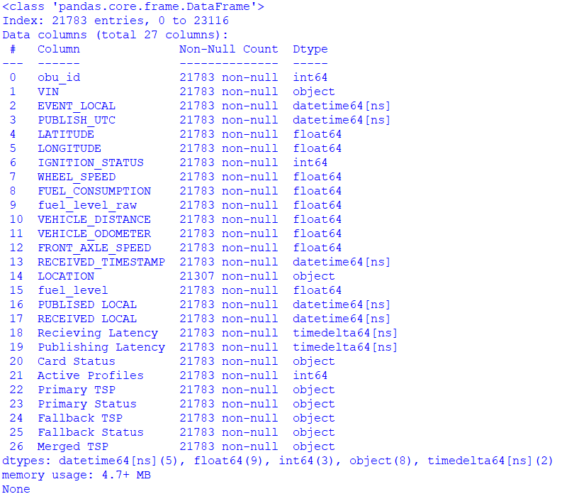

NOTE: The data here for example is only data of 10 vehicles but the actual project is checked with more data.

In our project, we doesn’t need the data’s having the “IGNITION_STATUS” to be zero and we are eliminating the unnecessary data with the help of dropna() function in pandas library of python. Likewise, many data are filtered out from the dataframe.

Df = df[df[‘IGNITION_STATUS’] != 0]

**3.4 Exploratory data analysis (EDA)**

Exploratory data analysis (EDA)involves examining and summarizing key characteristics, patterns, and relationships within a dataset. The primary goals of EDA are to uncover insights, identify patterns, and gain a better understanding of the data’s structure.

**3.4.1 Correlation:**

Find the correlation between different parameter using the function Corr() or using the conditions.

Datetime_columns = df.select_dtypes(include=[‘datetime64’]).columns

correlations_all_datetime = df[datetime_columns].corr()

plotting different types of graphs and analyzing them. Here is the data table of the correlation graph:

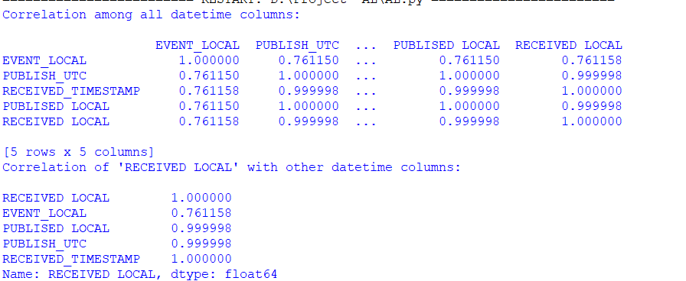

Heatmap:

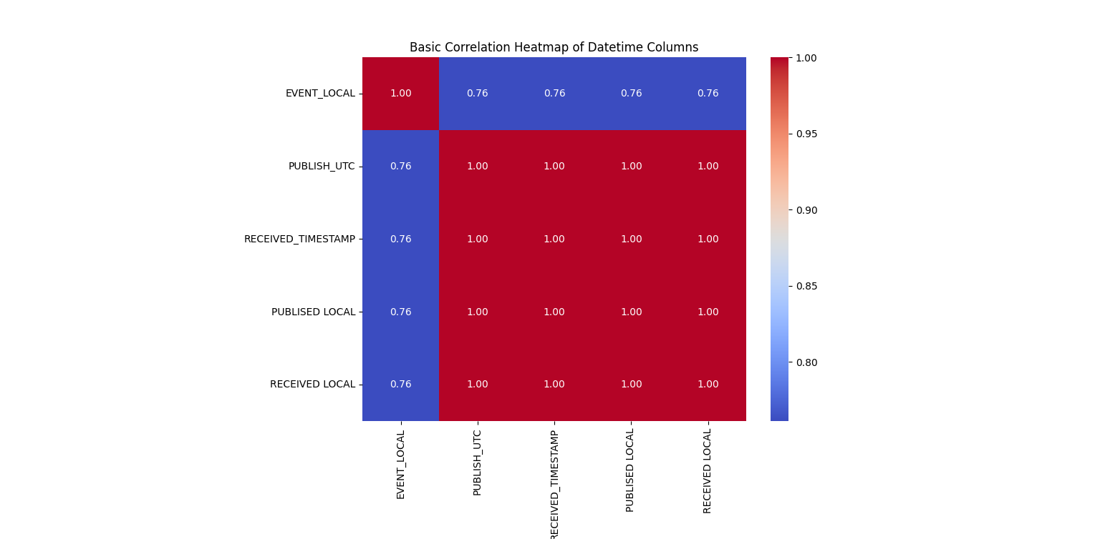

Bar Graph:

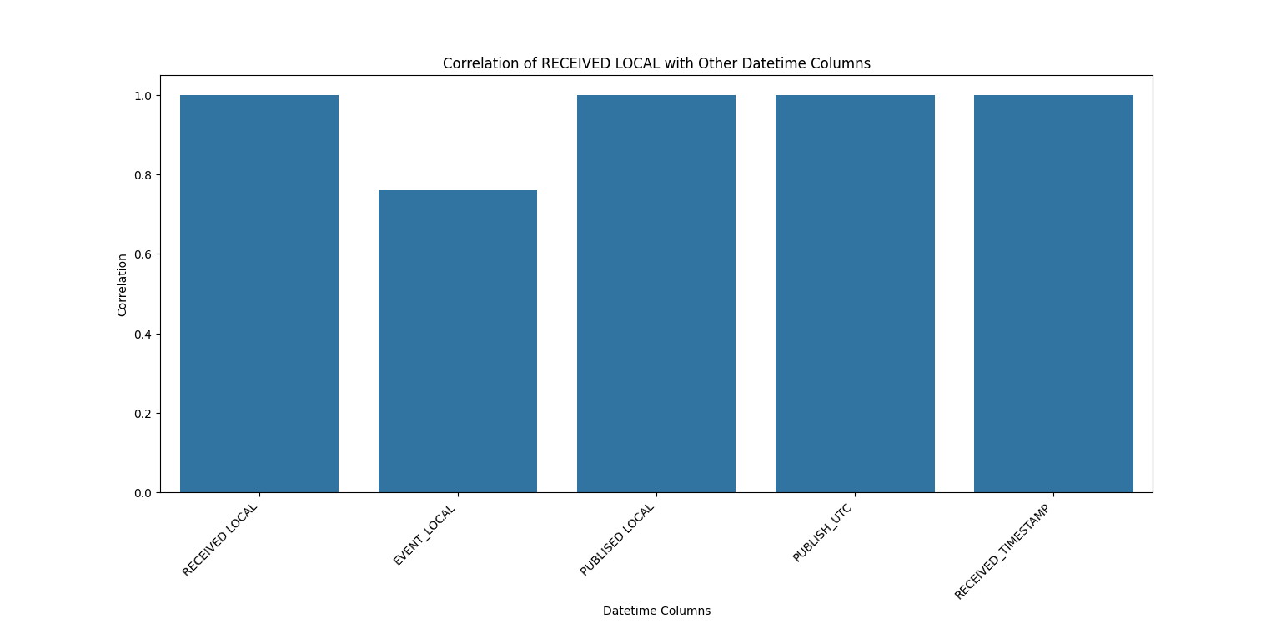

From the above given data we can see the deviation between the EVENT_LOCAL and RECEIVED_LOCAL. Now we have the parameters that should be targeted and project should be based on them.

**3.4.2 Linear Regression**

Linear regression is a statistical method used for modeling the relationship between a dependent variable (also known as the target or response variable) and one or more independent variables (predictors or features). The goal is to find the best-fitting linear relationship that can predict the dependent variable based on the values of the independent variables.

These are the graphs that plotted EVENT_LOCAL Vs all other parameters which are used in the correlation process

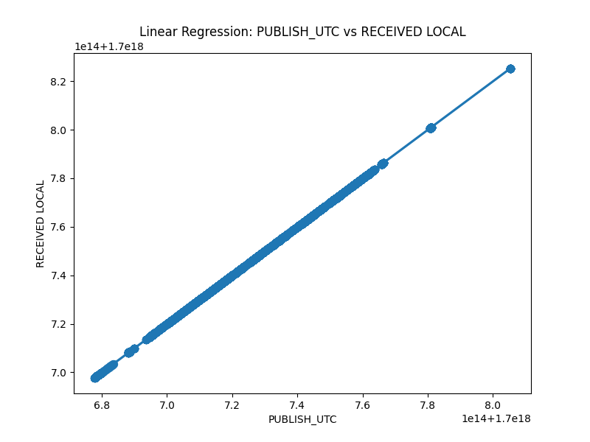

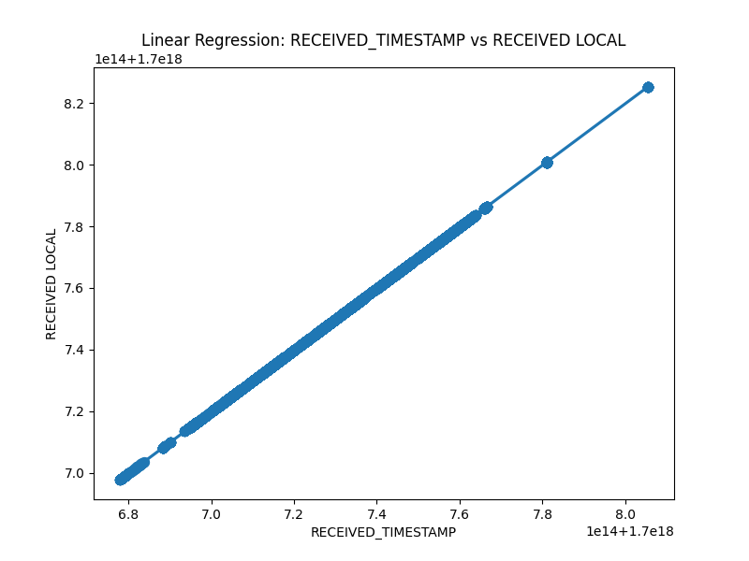

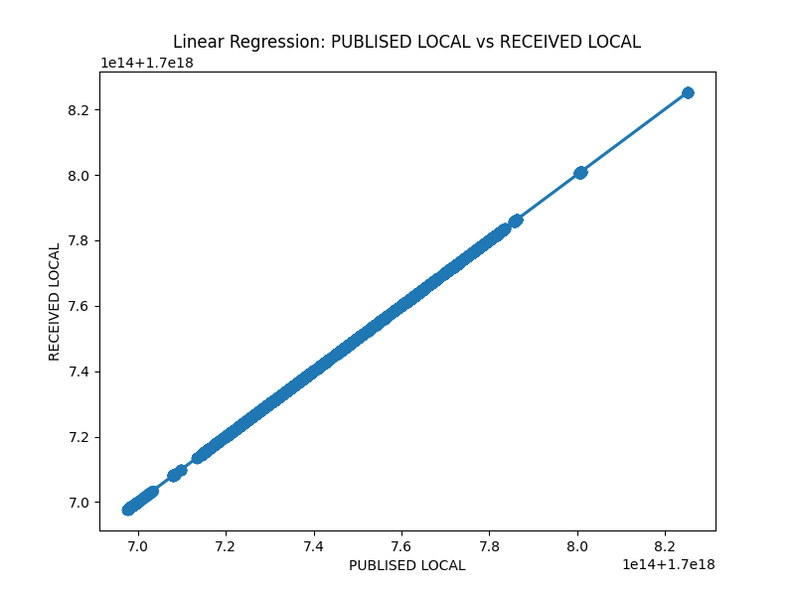

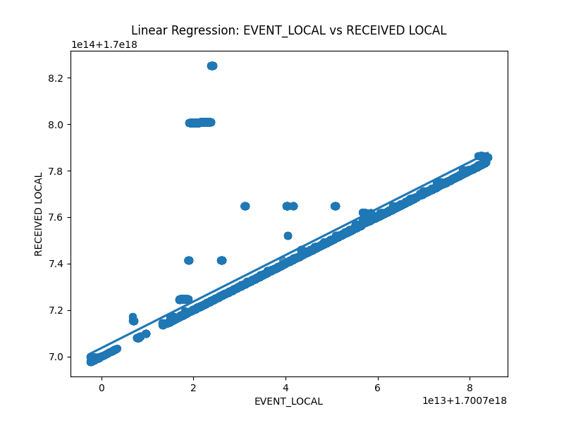

From the above graph between Event_local Vs Received_local , we get outliers with more deviations compared to all other graphs.

From the analysis of both correlation and linear regression we can conclude that there is a problem with Event_local Vs Received_local and now we can find the exact data deviation by the Binning.

**3.4.3 Binning**

From the given data we can find the latencies in timedelta Dtype. Here is the code snippet of that

df[‘Receiving Latency’] = pd.to_datetime(df[‘Receiving Latency’], dayfirst=True)  
df[‘Publishing Latency’] = pd.to_datetime(df[‘Publishing Latency’], dayfirst=True)  
df[‘Receiving Latency’] = df[‘RECEIVED LOCAL’] – df[‘EVENT_LOCAL’]  
df[‘Publishing Latency’] = df[‘PUBLISED LOCAL’] – df[‘EVENT_LOCAL’]

Binning, or discretization, is a technique in data analysis where continuous numerical data is divided into discrete intervals or “bins.” This is done to simplify the data, make it more manageable, and reveal patterns or trends.

In table form:

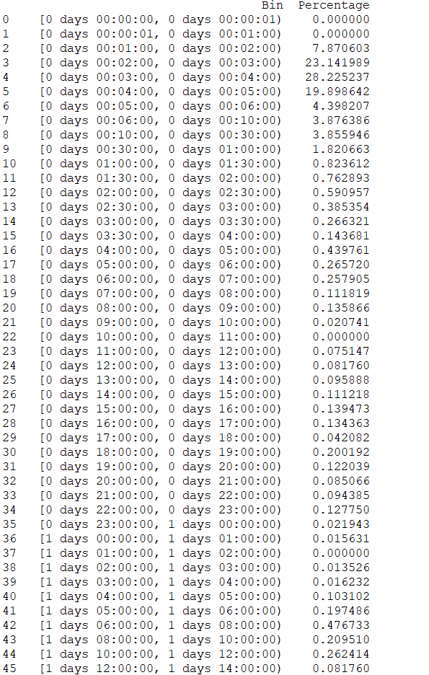

As Histogram:

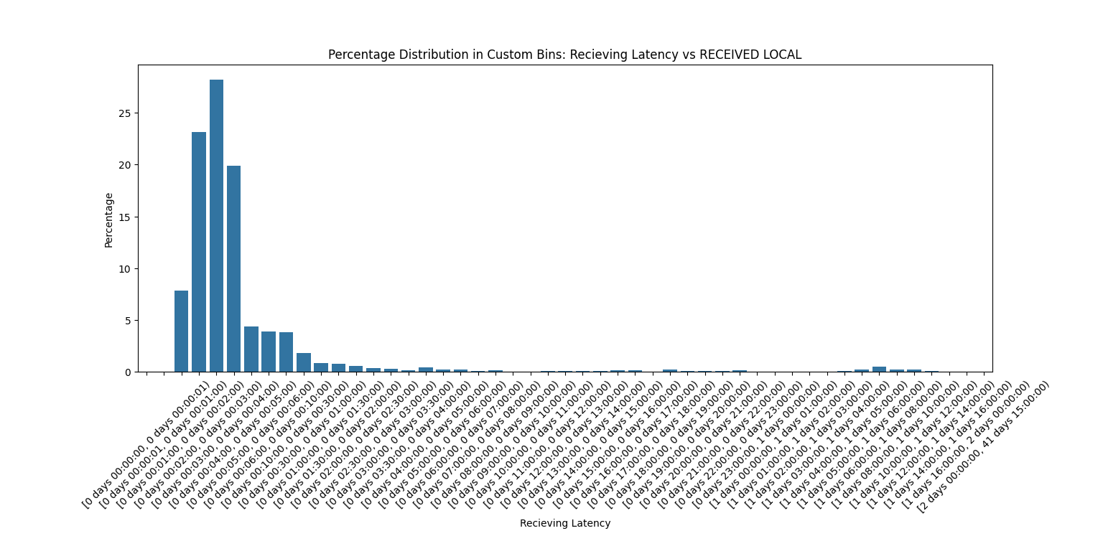

**CHAPTER 4**

**DATA VISUALIZATION**

Now with the rough idea we can visualize by utilizing several graphical techniques and implement them and conclude the problem.

**4.1 Event vs Publish**

Event local is the timestamp where the data of the vehicle is actually recorded by the ECU and Publish local is the timestamp which is recorded when the data have been uploaded/stored to the vendors database. By plotting a line plot between these two we can get the latency have occurred or not.

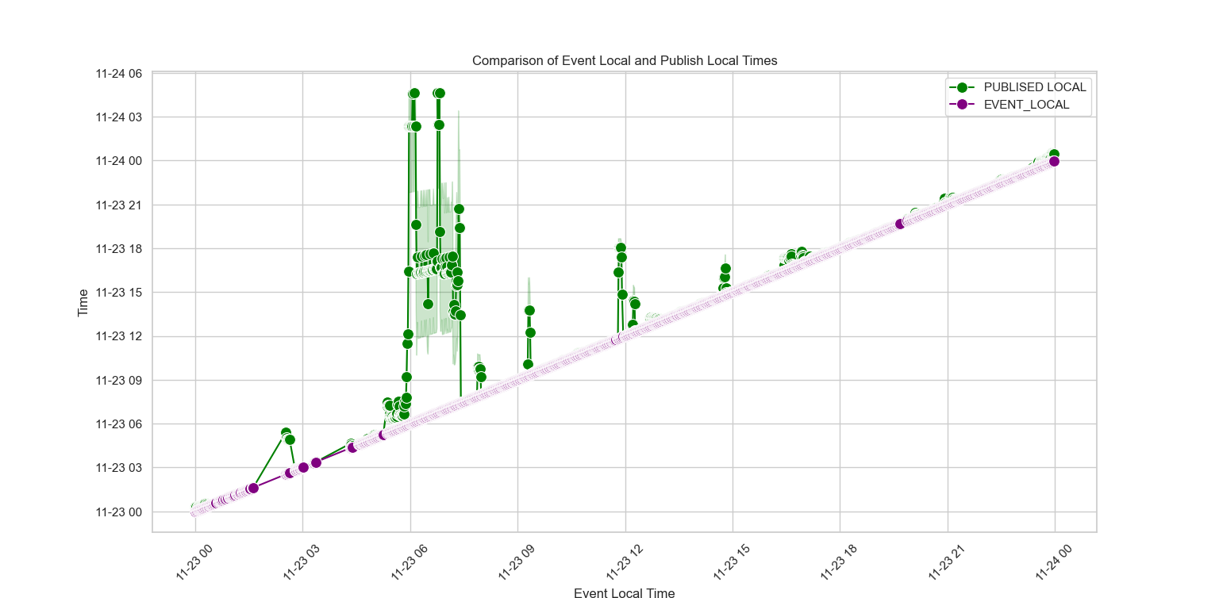

From the above graph we can conclude that there is a high latency issue between the ECU to the vendor database. We can conclude that this is the Reason for the latency occurrence.

**4.2 Relationship Between Publish and Received**

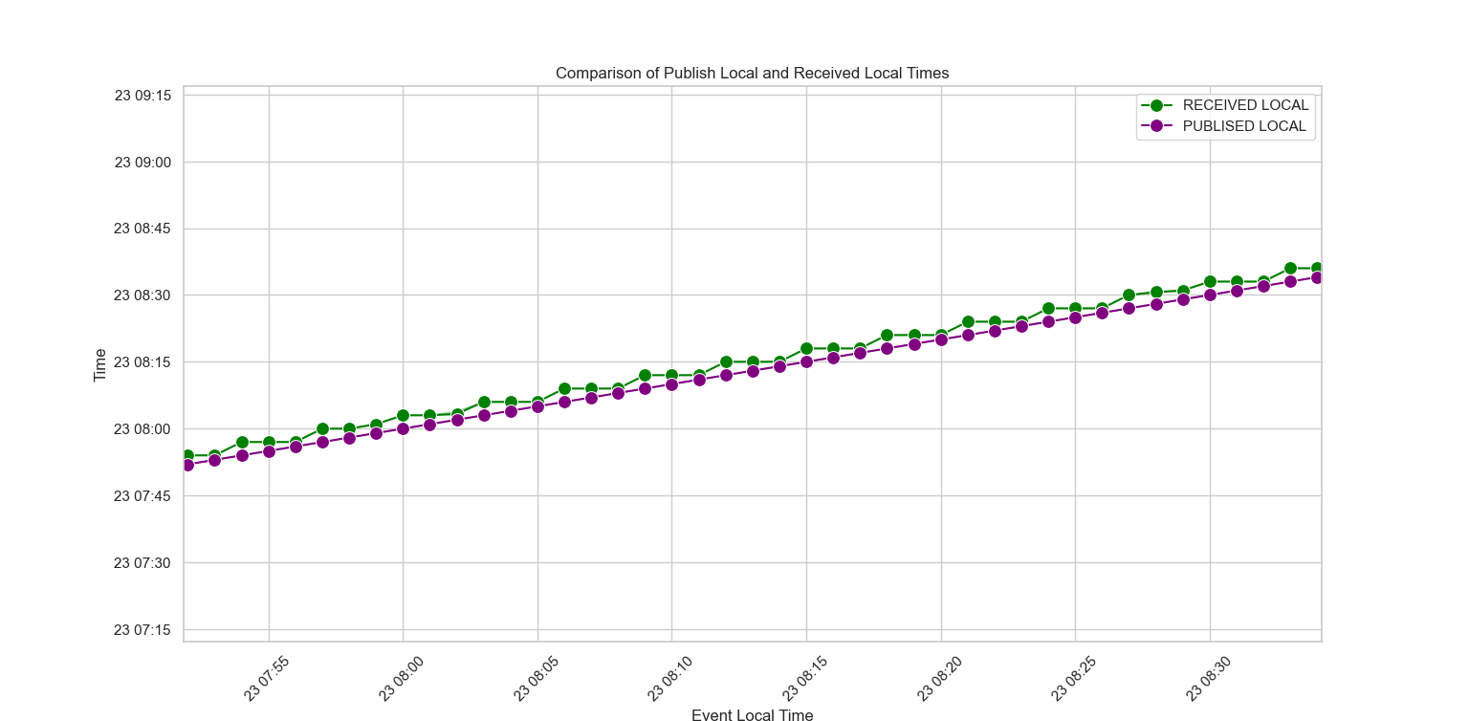

We can see the trend here that there is always a slight delay between the vendor database to company database. This is normal in transfer of data from one database to another database.

**4.3 REDZONE AREA**

For some specific range irrespective of the service providers or ECU damage or any hardware issues there is always a high latency and sometimes the signals gets interrupted and has no signals for some part. The reason behind this is due to the Forest Area where we don’t have much access for network to store in the database.

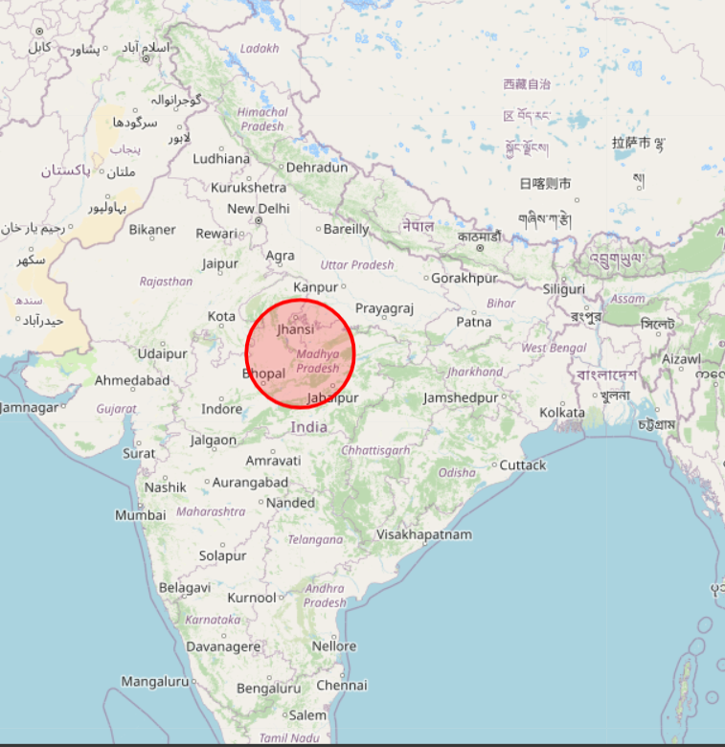

**4.4 SERVICE PROVIDERS**

Company using two service providers one as the primary TSP and a Fallback TSP. some vehicles have both the Service Providers Active and most of them have only one Service provider Active.

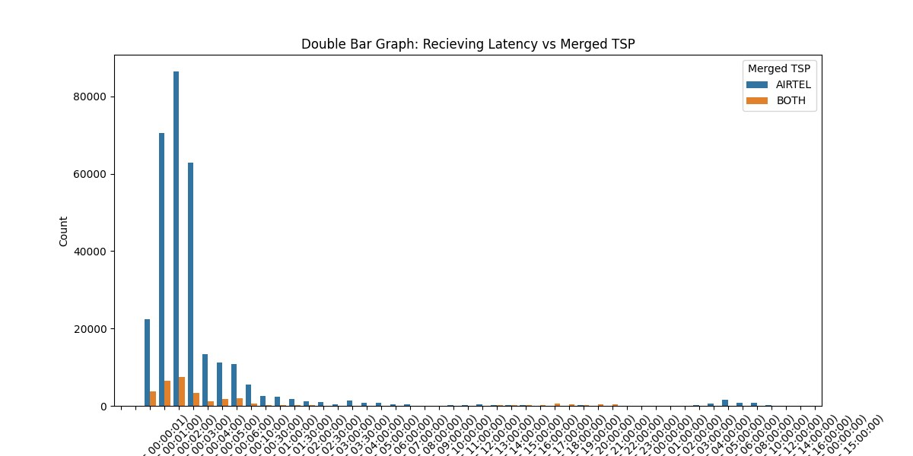

The graph is based on no of records of each signal in respective of the Service Providers.

To have a clear idea, converting them into the percentages on each bins we can observe the distribution of the Service provider for each latency.

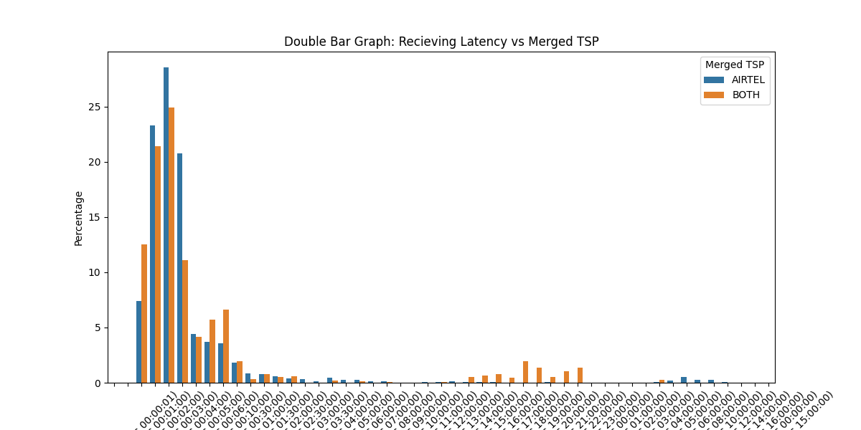

**CHAPTER 5**

**IMPLEMENTATION**

Plotting the Received Signals with latitude and longitude in the geographical map to find the exact location of each node. To have a clear observation, clustering them together by near radius.

By DBSCAN clustering, we can plot a map likewise,

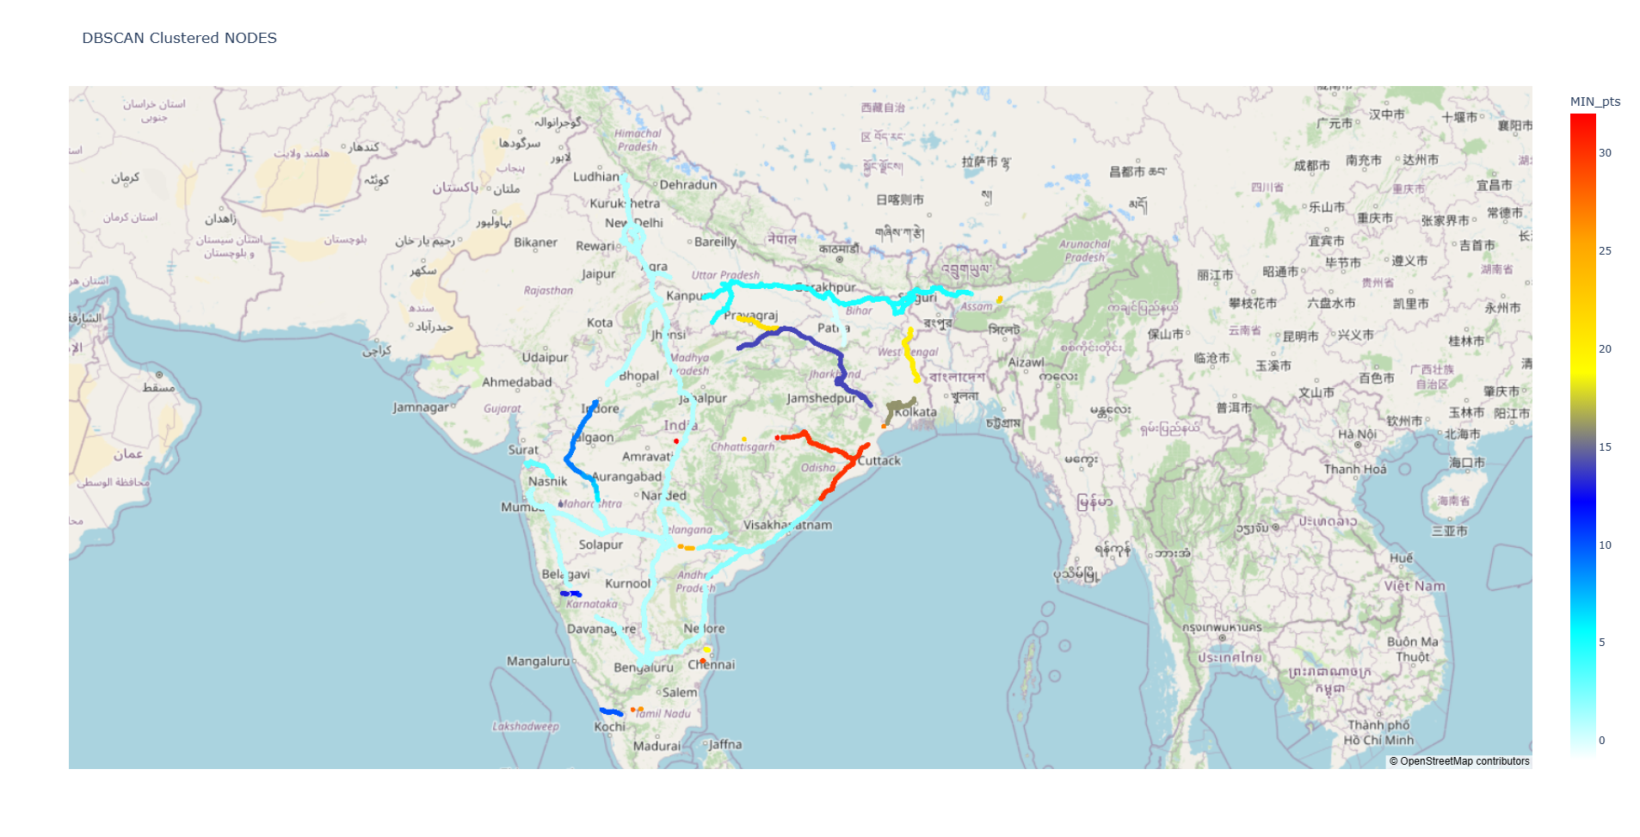

For information, Marking the cluster With the VIN numbers For Future Usage, we get vehicles map Route if we need to track the vehicles.

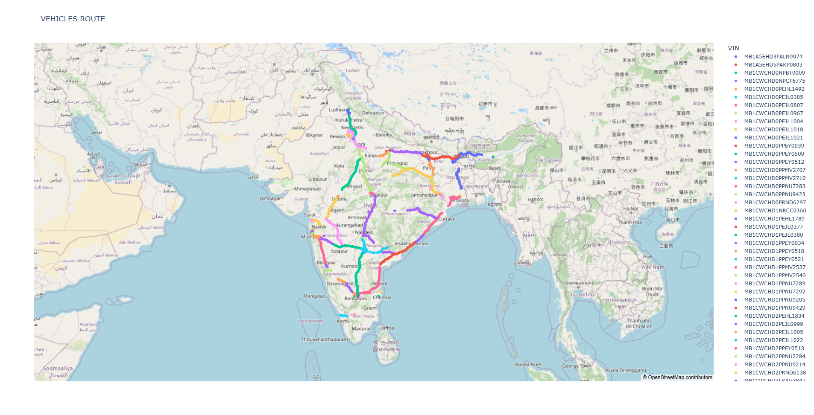



By plotting the Latency on the map with difference size to identify the cause of the latency problem.

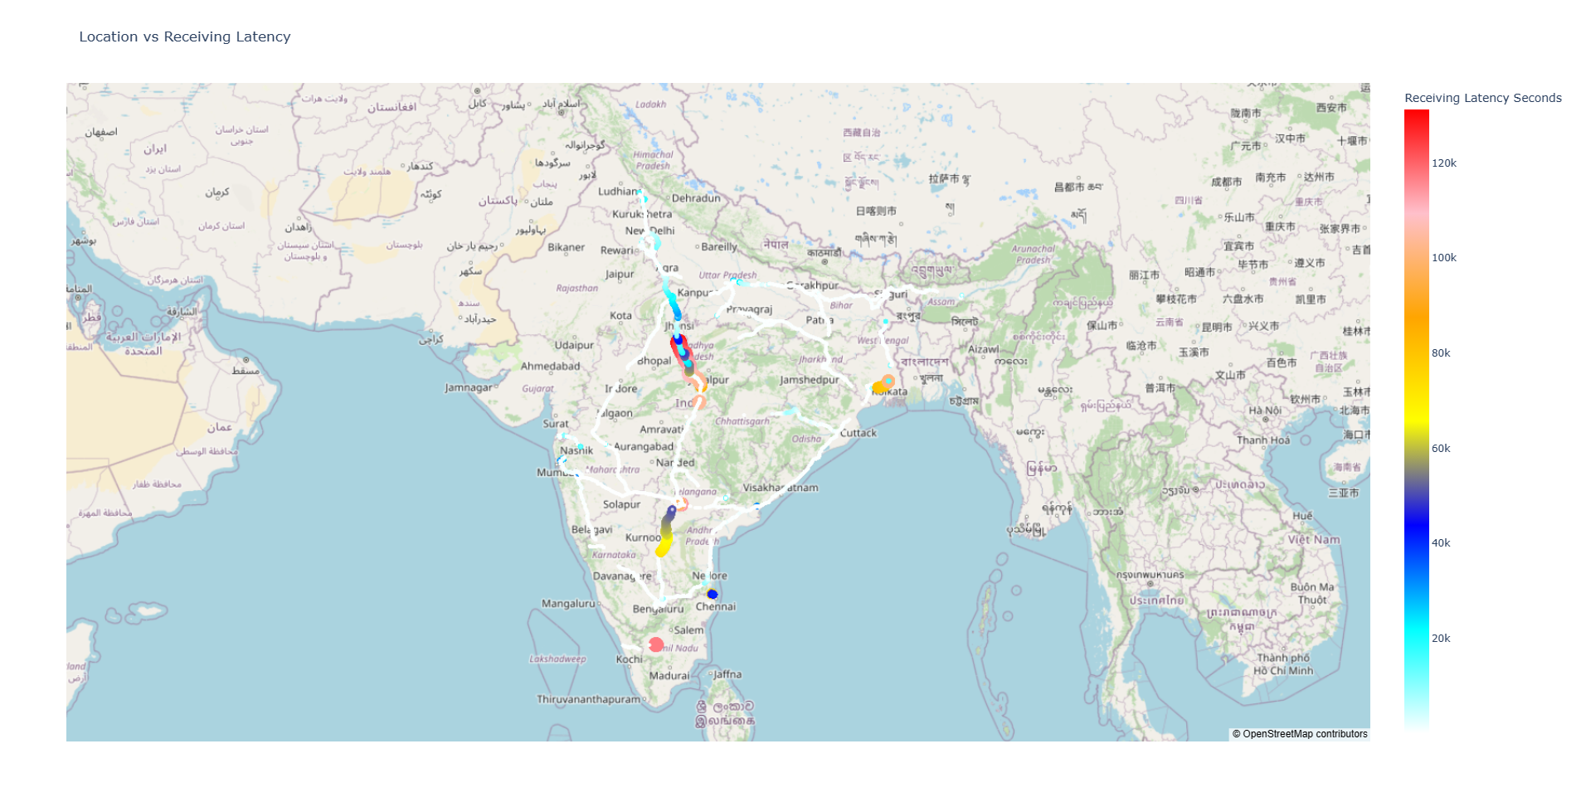

**CHAPTER 6**

**TABLEAU**

**6.1 INTRODUCTION**

Tableau is a leading data visualization and business intelligence platform. Renowned for its user-friendly interface, Tableau empowers users to connect to diverse data sources, create dynamic visualizations, and construct interactive dashboards with ease. Offering versatility in chart types and seamless integration with various data formats, Tableau facilitates insightful data exploration. Its collaborative features enable sharing and publishing of interactive reports, fostering effective communication. Whether used for ad-hoc analysis or advanced analytics, Tableau's impact spans industries, making data accessible and actionable for professionals seeking informed decision-making through compelling visual representations.

**6.2 VISUALIZATION**

Tableau Visualization is a transformative approach to deciphering complex datasets through compelling graphics. As a cornerstone of the Tableau platform, visualization tools enable users to translate raw data into insightful and interactive charts, graphs, and dashboards. With an intuitive drag-and-drop interface, Tableau empowers users to effortlessly create visually stunning representations of their data, fostering a deeper understanding of trends, patterns, and correlations. Whether showcasing geographical insights with maps or depicting trends over time with dynamic charts, Tableau Visualization provides a dynamic and accessible means for individuals and organizations to glean actionable insights from their data, ultimately driving smarter decision-making.

Here are some of the Screenshots from the tableau:

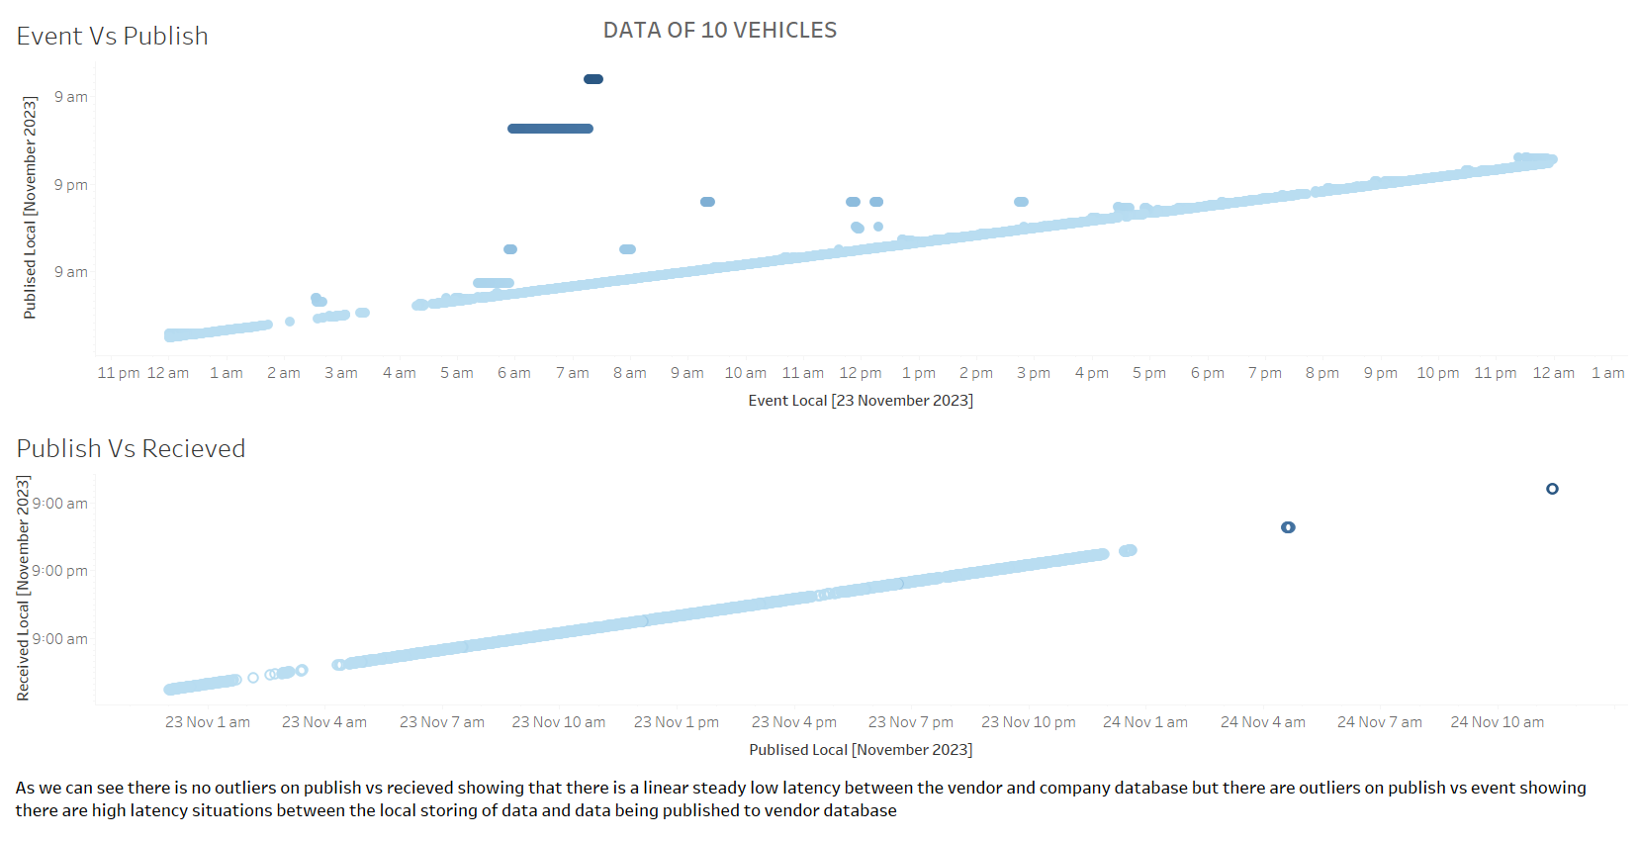

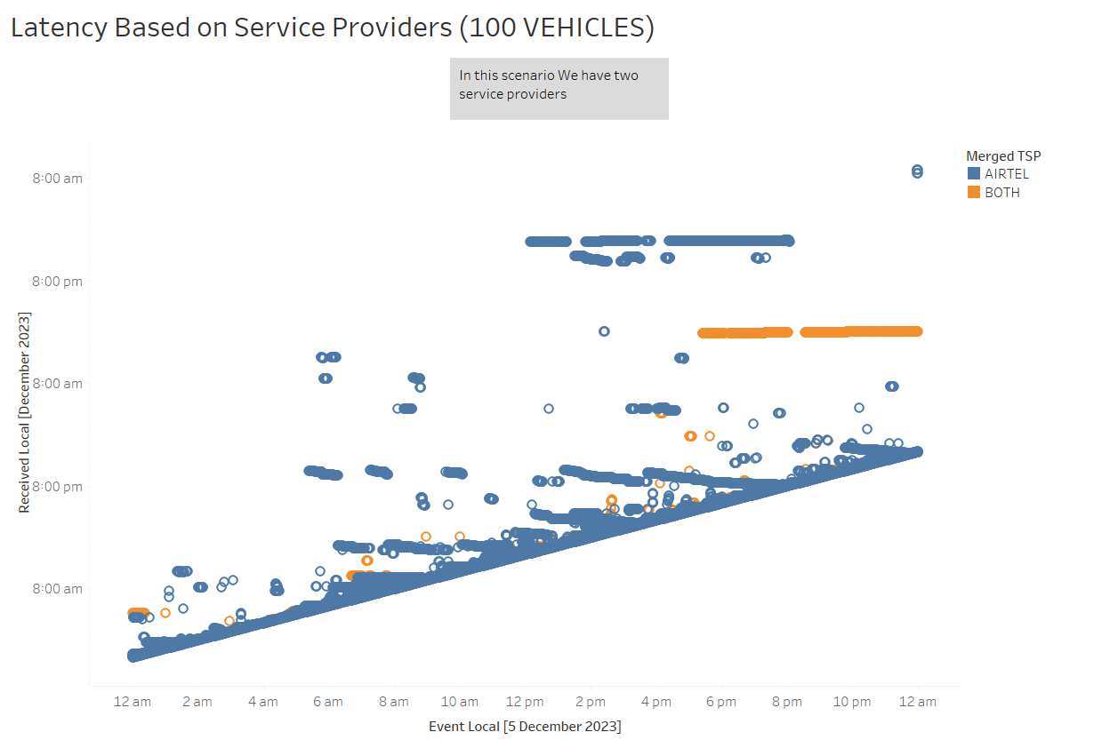

For Complete Tableau Report [Click Here](https://prod-apsoutheast-a.online.tableau.com/#/site/rishiramb/projects/469233?:origin=card_share_link)

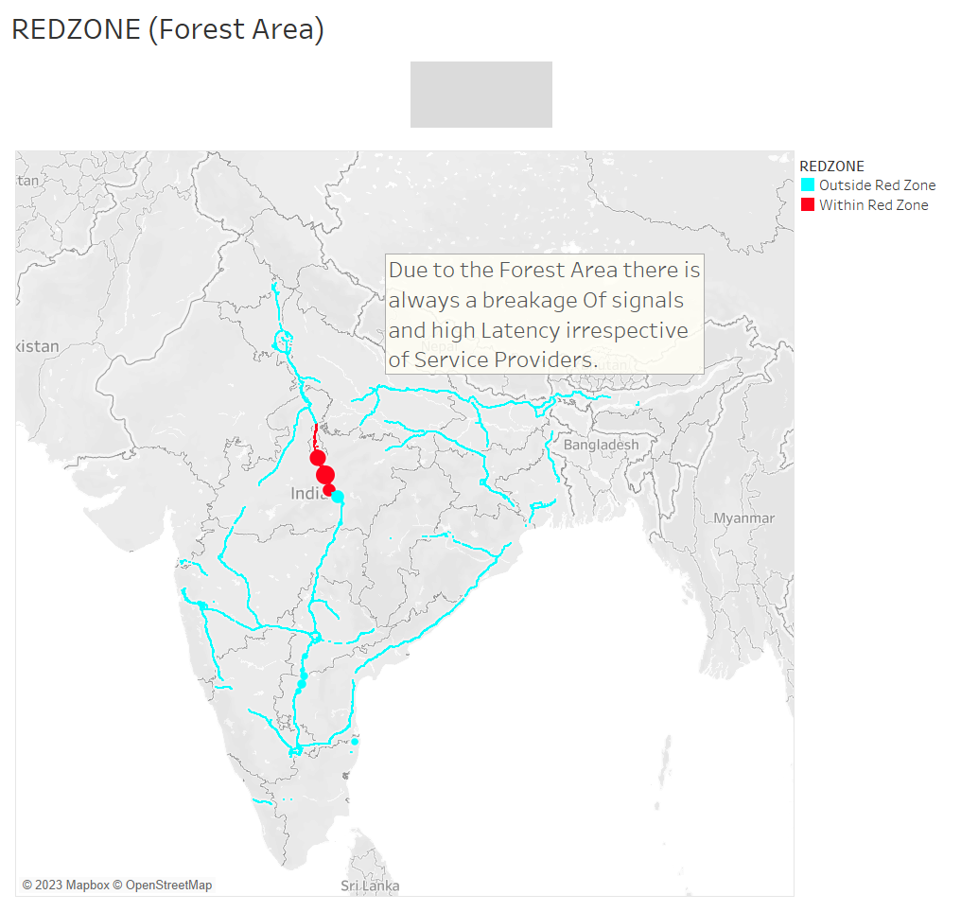

Then above map shows the redzone areas which is marked and with more data given, there can be more redzones found out. we can clearly see that the high latency is caused in red zone areas due to poor network connectivity because it is a forest region of Madhya Pradesh to Uttar Pradesh. irrespective of service providers or many other reasons, we will always have high latency and some worst cases we can expect the jumps in signal.

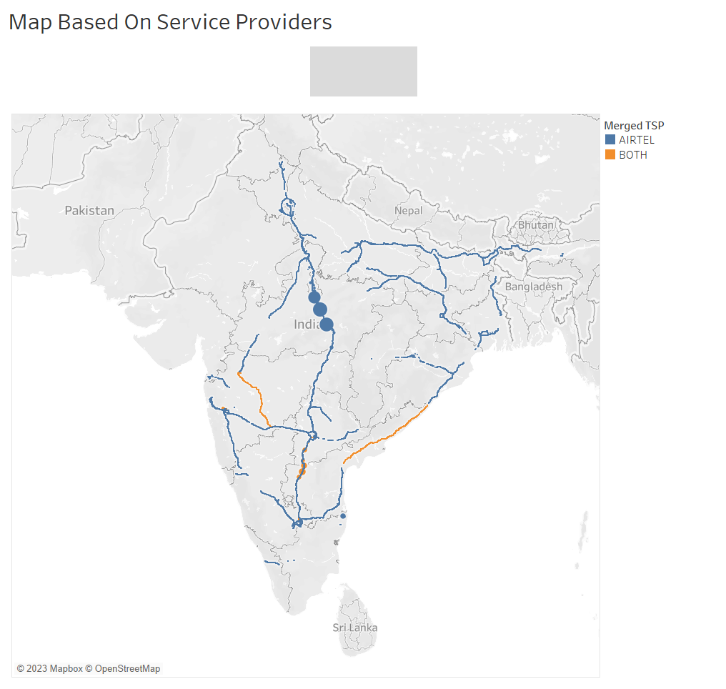

This map is to differentiate service providers in the map with the latency so that we can observe the latency of each service provider. From our given sample data, most of the vehicle have 1 active profile and majority of the service provider for them is AIRTEL. Ignoring the redzone area, AIRTEL doesn’t really have any high latency problem but vehicles with 2 Service providers have high latency and while analyzing the data, the primary TSP is BSNL which means we can assume that compared to BSNL, AIRTEL have reliable network and for further clarification we need more different kinds of sample data.

**CHAPTER 7**

**CONCLUSION**

**7.1 conclusion**

Big Data Analyzer is implemented to analyze the data given by the company and visualize them to get the clear idea and knowledge about the reason for the problem and to find various types of problems. After finding the correlation and binning of the received local we can say that there is no huge latency delay between the vendor database and the company database. the high latency is always caused between the ECU (event local) and the vendor database. Further moving on plotting the nodes in the map by the help of latitude and longitude we found out the route of each vehicle (by using VIN) .After analyzing the route We can now come to the conclusion that there is a high latency problem in the specific range as we have mentioned and irrespective of the service providers and many other problems, when the Vehicle is in the REDZONE there will be always high latency and in worst case sometimes we may not able to get signals. Other reason can be because of the service provider as we saw most of the vehicle uses AIRTEL and some vehicles have two active profiles in which we can Assume that the BSNL having the high latency comparatively to AIRTEL. some other reasons can be due to ECU hardware Damage, Vendor database Connectivity, Distance between server and the vehicles’ current location and can be because of poor configuration of ECU. In conclusion, there is no problem on company database and there are some REDZONES where the latency is always high with some possible difference in latency between service providers in the particular area.

**7.2 Future Enhancements and Recommendations**

The analyzer can be made more efficiently by adding some more parameters and data related to the service providers and types of networks they are using. analyzing the ECU to find the possibilities of any problems occurring. With the data given predicting the possible problem for occurrences instantaneously to make the work easy.

**CHAPTER 8**

**REFERENCES**

* <https://www.turing.com/kb/understanding-life-cycle-of-data-science-project>
* <https://www.tableau.com/products/desktop/download>
* <https://www.ibm.com/topics/exploratory-data-analysis>
* <https://datascience.stackexchange.com/questions/93711/how-to-calculate-the-distance-between-two-locations-using-haversine-formula>
* <https://seaborn.pydata.org/generated/seaborn.objects.PolyFit.html>
* <https://scikit-learn.org/stable/user_guide.html>
* <https://stackoverflow.com/questions/60886832/clustering-values-in-a-dataframe-in-python>
* <https://www.tutorialspoint.com/python/python_quick_guide.htm#:~:text=Python%20is%20a%20high-level,and%20cross-platform%20programming%20language>.